ASSIGNMENT-1

NOTE:

1. GREY COLOR LINES - COMMENTS FOR THE QUERY TYPE QUESTIONS.
2. BLUE COLOR LINES - QUERIES.
3. RED COLOR LINES - SCHEMA

**1.**

**1.1 Representing the Schema for each Relation in the University Database**

Schema for the **Student** Relation

**Student(sno, Surname, givename, major)**

Schema for the **Staff** Relation

**Staff(eno, surname, givename, department, rank)**

Schema for the **Class** Relation

**Class(cno, lecturer*, day, time, room)**

Schema for the **Enrol** Relation

**Enrol(sno*, cno*, grade)**

**1.2 Creating the Tables for each relation using the CREATE statement:**

Before creating a table it is mandatory to get assured that there is no duplicate table in the database (i.e., pre created table with the same table name that we are going to create). In order to achieve this we simply drop the tables in the order of their dependencies (i.e., taking constraints like foreign keys into consideration) by using the Drop statement.

Syntax:- drop table tablename;

**--Therefore,**

**--As Enrol table has the key constraints as foreign keys --from the Class table and Student table, it is in the highest --level and it should be dropped first.**

**drop table Enrol;**

**--Similar, in the case of Class table which has the keys --from Staff table.**

**drop table Class;**

**--Dropping the remaining tables as usual as they are --independent tables.**

**drop table Staff;**

**drop table Student;**

**-- Now Creating the required tables in the order of --Student, Staff, Class and Enrol, this is because of --their dependencies which requires one table to --create before creating another**

**-- Create table for the Student Relation**

**create table Student (**

**sno varchar(6) primary key,**

**surname char(12),**

**givename char(10),**

**major char(10)**

**);**

**--Create table for the Staff Relation**

**create table Staff(**

**eno varchar(6) primary key,**

**surname char(20),**

**givename char(20),**

**department char(30),**

**rank char(30)**

**);**

**--Create table for the Class Relation**

**create table Class(**

**cno varchar(20) primary key,**

**lecturer varchar(10),**

**day varchar(10),**

**time varchar(10),**

**room varchar(15),**

**CONSTRAINT Staff_eno_fk foreign key(lecturer) references Staff(eno)**

**);**

**--Create table for Enrol Relation**

**create table Enrol (**

**sno varchar(10),**

**cno varchar(10),**

**grade varchar(10) UNIQUE,**

**CONSTRAINT student_sno_fk foreign key(sno) references Student(sno),**

**CONSTRAINT class_cno_fk foreign key(cno) references Class(cno),**

**CONSTRAINT table_pk primary key(sno, cno)**

**);**

**1.3 INSERT INTO Statements to create a sample database**

**--Insert data into Student Table**

**insert into Student(sno, surname, givename, major) values('s1001', 'Smith', 'Tom', 'History');**

**insert into Student(sno, surname, givename, major) values('s1002', 'Chin', 'Ann', 'Maths');**

**insert into Student(sno, surname, givename, major) values('s1003', 'Lee', 'Perry', 'Arts');**

**insert into Student(sno, surname, givename, major) values('s1005', 'Smith', 'John', 'History');**

**insert into Student(sno, surname, givename, major) values('s1006','River','Jane','Art');**

**--Insert Data into Staff Table**

**insert into Staff(eno, surname, givename, department, rank) values('e123','Bowl','Alex','Maths','Lecturer');**

**insert into Staff(eno, surname, givename, department, rank) values('e205','Cox','Kevin','CSC','Associate Professor');**

**insert into Staff(eno, surname, givename, department, rank) values('e301','Jones','David','Arts','Senior Lecturer');**

**--Insert Data into Class Table**

**insert into Class(cno, lecturer, day, time, room) values('isys155','e123','Wed','17:30','80.01.12');**

**insert into Class(cno, lecturer, day, time, room) values('cosc121','e205','Thu','08:30','12.10.02');**

**insert into Class(cno, lecturer, day, time, room) values('artc131','e301','Mon','10:30','10.08.09');**

**insert into Class(cno, lecturer, day, time, room) values('cosc101','e205','Tue','14:30','14.09.05');**

**--Insert Data into Enrol table**

**insert into Enrol(sno, cno, grade) values('s1001', 'isys155', 'HD');**

**insert into Enrol(sno, cno, grade) values('s1003', 'cosc121', '');**

**insert into Enrol(sno, cno, grade) values('s1005', 'artc131', 'CR');**

**insert into Enrol(sno, cno, grade) values('s1006', 'cosc101', '');**

**2. The Schema for the Academics Database is given below:**

**DEPARTMENT(deptnum, descrip, instname, deptname, state, postcode)**

**ACADEMIC(acnum, deptnum*, famname, givename, initials, title)**

**PAPER(panum, title)**

**AUTHOR(panum*, acnum*)**

**FIELD(fieldnum, id, title)**

**INTEREST(fieldnum*, acnum*, descrip);**

**2.1 Explanation of the SQL Query**

**SELECT fieldnum, title**

**FROM field**

**where (fieldnum>=500 and fieldnum<=599)**

**or (upper(title) like 'DATA %'**

**or upper(title) like '% DATA %'**

**or upper(title) like '% DATA');**

The above query extracts the attributes fieldnum, title from the field table by verifying the condition specified in the where clause by verifying the condition and if the where clause fails then the OR statements will be verified i.e., the title will be converted into uppercase statement using the upper() and search for the pattern mentioned with like(%) Operator. The query will Executes in the following order:

1. **FROM ->** In the first step it retrieves all the data stored in the particular table mentioned i.e data from table “field”.
2. **WHERE ->** In the second step it checks whether the condition specified in the where clause is satisfied or not.

Condition1:

It checks for the filednum must be greater than or equals to 500 and must be less than or equal to 599.

Condition2:

If the condition fails then it will execute the OR statements which states that the title must contain the word DATA.

It again holds 3 individual conditions such as:

(upper(title) like 'DATA %')

The above condition converts he whole title into uppercase

using the upper() and checks for the word DATA at the beginning of the title and can be checked with like operator. or upper(title) like '% DATA %'

The above condition checks for the word DATA at the middle of the title and can be checked with like operator.

or upper(title) like '% DATA'

The above condition checks for the word DATA at the end of

the title and can be checked with like operator.

1. **SELECT->** In the final step it selects the required fields from the given table i.e., fieldnum, title from the table “field”.

Therefore, the output consists of the titles from the fieldnum 500 to 599 and the titles which has the pattern data.

**--2.2 Correction of the SQL Query**

**--Given SQL Query:**

**--Select panum, title**

**--From author. Interest, paper**

**--Where author.acnum =interest.acnum;**

**--The Correct Query for the given incorrect query is given --below**:

**Select PAPER.PANUM, PAPER.TITLE, AUTHOR.ACNUM, INTEREST.FIELDNUM**

**From AUTHOR, INTEREST, PAPER**

**Where AUTHOR.PANUM = PAPER.PANUM and AUTHOR.ACNUM = INTEREST.ACNUM;**

**--2.3 Number of academics in the department --where deptnum is 100 is-**

**select count(*)**

**from ACADEMIC**

**where DEPTNUM = 100;**

--The above SQL Query gives the count of the total --academics in the Academic table with deptnum 100.

**--2.4 Listing the titles of all papers in an --alphabetical order**

**SELECT \***

**FROM PAPER**

**ORDER BY TITLE ASC;**

--The SELECT * statement selects all the titles from the --PAPER table by ordering them(by using ORDER BY) in --ascending order(ASC) thereby produces the result in an --alphabetical order.

**--2.5 Returning the Details research fields in which --titles starting with the word DATA-**

**SELECT FIELDNUM, TITLE**

**FROM FIELD**

**where TITLE like 'Data %';**

--The above Query gives the FIELDNUM and the TITLE --from the FIELD table in which the title must start with the --word DATA.

**--2.6 Query to list the panum, title and author --acnum of each paper-**

**--Query:**

**Select PAPER.PANUM, PAPER.title, AUTHOR.ACNUM**

**From AUTHOR, PAPER;**

--The above Query gives the panum from the AUTHOR --table and the title from the PAPER table and the ACNUM --from the AUTHOR table.

**--2.7 Give the famname and givename of --academics working for 'RMIT CS'**

**Select ACADEMIC.FAMNAME, ACADEMIC.GIVENAME**

**From ACADEMIC, DEPARTMENT**

**Where (ACADEMIC.ACNUM >= 200 and ACADEMIC.ACNUM <= 299)**

**AND DEPARTMENT.DESCRIP = 'RMIT CS'**

**ORDER BY ACADEMIC.FAMNAME, ACADEMIC.GIVENAME ASC;**

--The above query gives the famename and givename --from ACADEMIC table from ACNUM 200 to 299 and the --descrip must be RMIT CS in the ascending order.

**--2.8 Give the famname and givenname for --institutions in Victoria.**

**Select ACADEMIC.FAMNAME, ACADEMIC.GIVENAME**

**From ACADEMIC, DEPARTMENT**

**Where DEPARTMENT.STATE = 'VIC' OR DEPARTMENT.STATE = 'Vic';**

--The above query gives the famname and the givename of --ACADEMIC which works for the state VICTORIA.

**--2.9 Searching for the academics which do not --have titles.**

**Select FAMNAME, GIVENAME**

**From ACADEMIC**

**Where TITLE is null**

**ORDER BY FAMNAME, GIVENAME ASC;**

--The above query gives the givenname and the famname --from the ACADEMIC table in which the academics have --no title in an ascending order.

**--2.10 Number of Institutions in the Database**

**Select count(DISTINCT instname)**

**from DEPARTMENT;**

--The above Query gives the count of the institutions in the --database and the DISTINCT keyword eliminates the --duplicates in the instname.

**3. ER Diagram for the data of an Online Multiplayer Team Game.**

It can be drawn in the following ways,

1. With the legendary_game class containing level attribute.

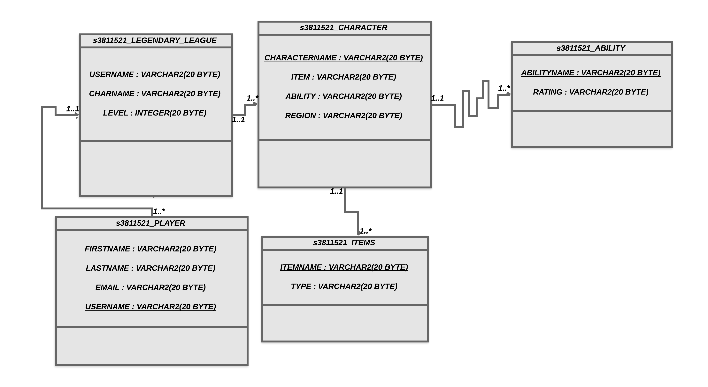

In the above ER-Diagram the LEGENDARY_LEAGUE table was introduced and related to the character and the player table with “HAS” Relation through 1 : n relationship which means that the League will have number of players and number of characters.

In the s3811521_Legendary league table –

It has three attributes namely,

--CHARNAME – Denotes the name of the character in character table

--USERNAME - Denotes the name of the user in player table

--LEVEL –Denotes the level of the player in the game.

The Game can have any number of players and each player can have n - number of characters. The character may change for every game but the level of the player should remain same until the rating get varies.

In the Player table—

USERNAME is unique

FIRSTNAME, LASTNAME and EMAIL are the attributes.

Each player has one or more characters stored in the Character table and the relation between player table and the Character table can be represented with 1 : n relation.

In the Character table—

CHARNAME is unique

ITEM, REGION, ABILITY are the attributes.

Each Character can have one or more Items and can have one or more abilities. The region in the Character table describes that the character must be from a particular region and that should be mentioned with the keyword unique.

In the Item table—

ITEMNAME is unique

ITEMTYPE is an attribute.

Itemtype describes the type of item that the character holds and the relationship between character and the item table can be mentioned with 1 : n relation.

In the Ability table—

ABILITYNAME is unique.

RATING is an attribute.

As it is mentioned that the Character can have one or more abilities and the relationship can be represented with 1 : n relation between character and the Ability table.

1. **Without the LEGENDARY_GAME class containing level attribute.**

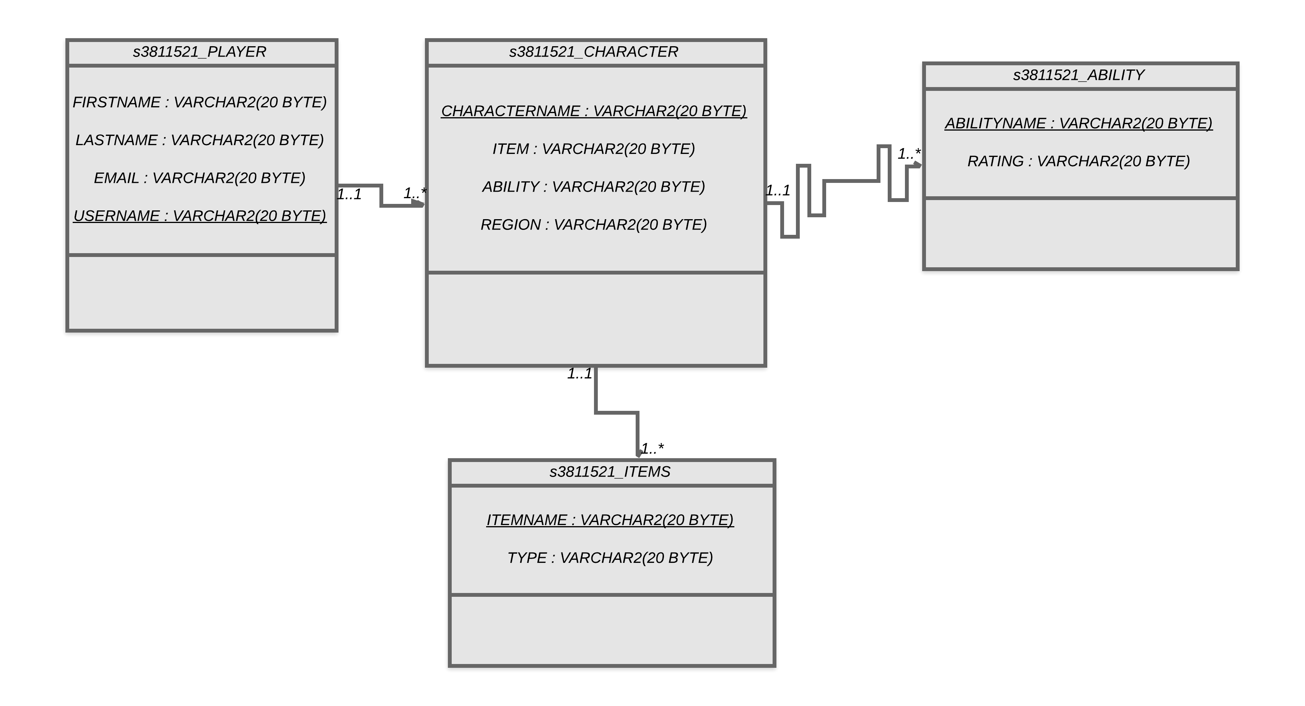

In the above Entity Relationship diagram for the Legendary game database, Consider four tables namely Player, Character, Ability and Item.

In the Player table—

Username is unique.

Firstname, lastname and Email are the attributes.

The Game can have any number of players and each player can have n - number of characters. The character may change for every game but the level of the player should remain same until the rating get varies.

In the Player table—

USERNAME is unique

FIRSTNAME, LASTNAME and EMAIL are the attributes.

Each player has one or more characters stored in the Character table and the relation between player table and the Character table can be represented with 1 : n relation.

In the Character table—

CHARNAME is unique

ITEM, REGION, ABILITY are the attributes.

Each Character can have one or more Items and can have one or more abilities. The region in the Character table describes that the character must be from a particular region and that should be mentioned with the keyword unique.

In the Item table—

ITEMNAME is unique

ITEMTYPE is an attribute.

Itemtype describes the type of item that the character holds and the relationship between character and the item table can be mentioned with 1 : n relation.

In the Ability table—

ABILITYNAME is unique.

RATING is an attribute.

As it is mentioned that the Character can have one or more abilities and the relationship can be represented with 1 : n relation between character and the Ability table.

1. **On SQL developer we will get the below diagram,**

